Natural Edge Crescent Bowl
By Paul Coppinger
Abstract
Crescent bowls, where the length is greater than the width, may be turned from limbs, small logs or half a log. By using wood with the bark on, the Crescent bowl will have a natural edge. The described procedure will require a 3 step process to form the bottom with a tenon, hollow the inside of the bowl and the use of a jam chuck to remove the tenon.
Equipment
Spur drive
Oneway Talon chuck or equivalent, with #2 jaws
Live Center with point
Bowl gouge with side grind
Small Spindle gouge
Procedure
Wood
For small bowls, use a limb or tree truck under 6” diameter. Cut the length to 1 1/3 the diameter, minimum. For example, if the limb is 3” diameter, cut the length to at least 4” (3 x 1 1/3 = 3 x 4/3 = 4).
For large bowls, use either the entire log or a half log. Use the same length-to-width ratio (4/3 diam = length, min) on either the entire log or on a half log.
Regardless of small or large wood, remember that the length cannot be longer than the lathe capacity. If using a mini lathe with a 5” throw, then 10” is the maximum length that will fit the lathe.
Safety
- Use a facemask when shaping the bottom.
- Lower the speed before turning on
- Step to the side when turning on to prevent bark, dirt or the wood from hitting you
- Always turn off the lathe to adjust the tool rest

Orientation
Use a spur drive and the tailstock live center to mount. The spur drive should be at the midpoint of the wood length and the tailstock should be adjusted to center the limb or flat of a half log, both for length and width. When oriented correctly, the wood should be perpendicular to the lathe when viewed from the side and centered when viewed from the end. As you begin shaping, it may be necessary to adjust the live center to achieve a balanced bowl base, see Fig 1.
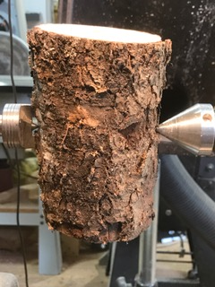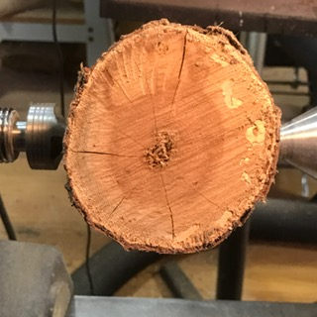
Fig 1A. Vertical orientation Fig 1B. Horizontal orientation
The live center point will form an alignment hole necessary for the last step, removal of the tenon.
Shaping of Crescent Bowl bottom
The bottom of the bowl will be the live center side of the wood or the flat of a split log. Begin using 3-45 pull cut where the tool rest is 45 degrees to the lathe, the bowl gouge handle is dropped at 45 degrees and the flute is at 45 degrees. Think of the gouge as an analog clock face when held vertical. The tip of the gouge will be 12 o’clock and the handle bottom will be 6 o’clock. Pull the gouge by the wood using a very light cut at the 11 o’clock position. (Do not cut using the side grind of the gouge or you will very likely get a catch.) See Fig 2.
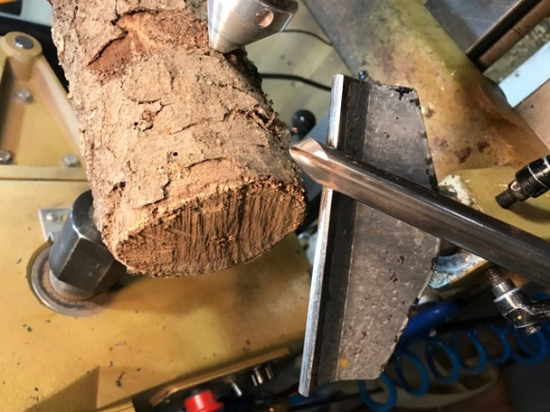
Fig 2. 3-45 pull cut
If the wood slips on the spur drive, increase the pressure of the tailstock. Keep the tool rest close to the wood to maximize the leverage of the tool handle giving you more tool control. Adjust the tool rest angle as you shape the bowl bottom to keep the rest close to the cutting point, see Fig 3.
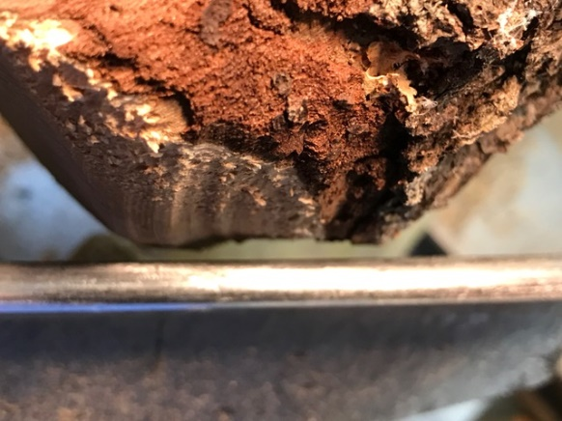
Fig 3. Adjusted tool rest to keep rest close to cutting point
Continue shaping the bottom until the end flats are removed. Cut a tenon about ¼” long by 1 ½” minimum wide for the chuck jaws keeping the inside corner square. As you shape the bottom, the narrow bowl sides should begin to “pull up” and be symmetrical. If they are not symmetrical (see Fig 4.), adjust the location of the live center or spur drive. Any adjustment will require reshaping the long side of the bottom.
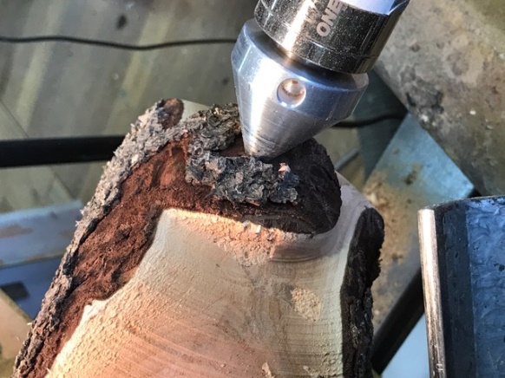
Fig 4. Unsymmetrical sides of the bowl requiring adjustment of the live center or spur drive
Shaping of Crescent Bowl top
Remove the completed bowl bottom from between the spur drive and live center, replace the spur drive with a chuck and insert the tenon into the chuck jaws. Position the tool rest perpendicular to the lathe and begin removing the bark from the center of the limb or split log. Do not remove the bark from the edge of the piece. Using a bowl gouge with a fingernail grind, close the flute, hold the tool horizontal and orient the tool angle such that the tool bevel at the 12 o’clock position is perpendicular to the wood. Push the tip of the tool into the wood about 1/8” from the edge. See Fig 5.
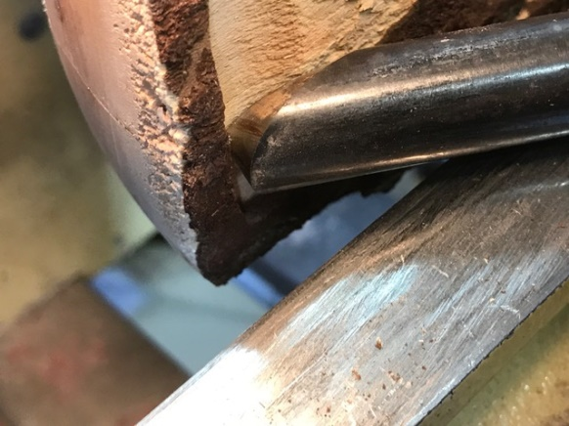
Fig 5. Bowl gouge beginning a bowl hollowing cut on ends
As soon as you establish a small shoulder in the wood, begin opening the flute while dropping the handle, pushing a cut parallel to the outside of the bowl and around the beginning of the inside bowl corner. Do not cut to the center of the bowl. Because the ends of the crescent will be thin and unsupported, it is important to leave wood (mass) in the center of the bowl to prevent flexing of these ends. Repeat the bowl cut to thin the crescent wall to the desired thickness. Because these thin walls will flex when rotating, complete the thinning only down to the beginning of the side walls, see Fig 6.
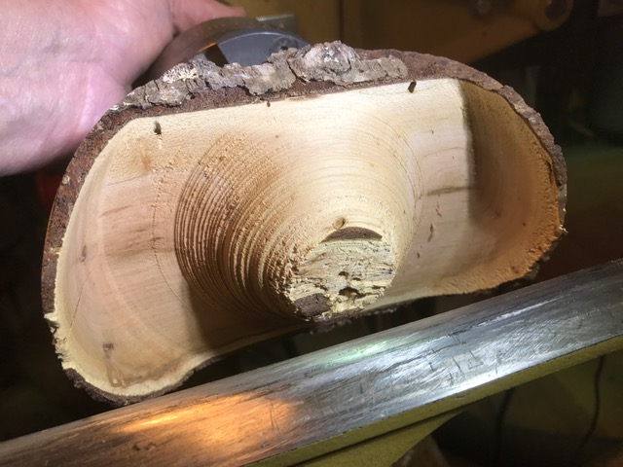
Fig 6. Thinned, flexible Crescent Bowl ends down to side walls, leaving mass in center
When the crescent walls are at the desired thickness, then complete the removal of the lower side walls and center wood. Sand inside and outside.
Tenon Removal
Begin by making a jam chuck. Install a piece of scrap wood approximately the diameter of the inside bottom of the bowl. Turn the scrap until the profile is close to the curvature of the inside of the bowl. It doesn’t have to be exactly the same curvature. Use a folded sheet of paper towels, thin rubber sheet or a piece of a mouse pad between the jam chuck and the inside of the bowl. Use the point of the tailstock in the alignment hole to orient and hold the bowl. Use a bowl or small spindle gouge to remove the tenon by cutting along the axis of the lathe, not across. (Cutting across applies pressure which can force the tailstock point out of the alignment hole.) As the tenon is removed, an inverted cone will be formed under the tailstock point. Undercut the surface of the tenon making a concave shape and reduce this cone to about 1/8”. Remove the crescent bowl from the lathe, use a sharp knife to cut the 1/8” cone off, then sand the bottom to remove any high spots. The crescent bowl should sit on the outside of the bottom and not wobble.
Completed examples of natural edge bowls are shown below. 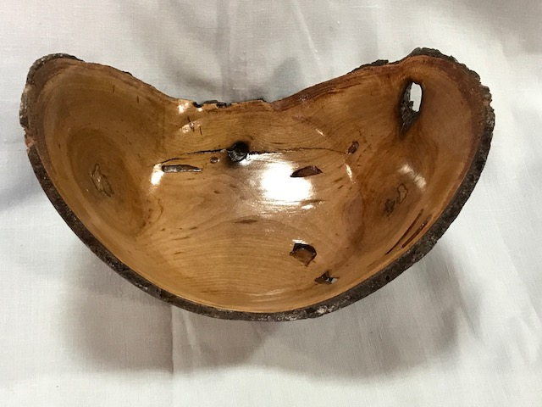
Cherry, 1.5 Length-to-Width Ratio Bowl
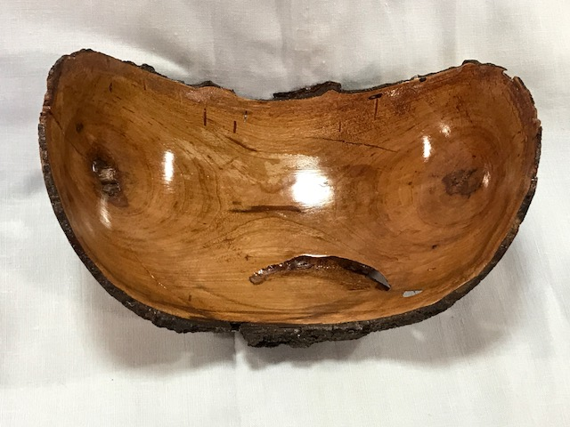
Cherry, 1.5 Length-to-Width Ratio Bowl
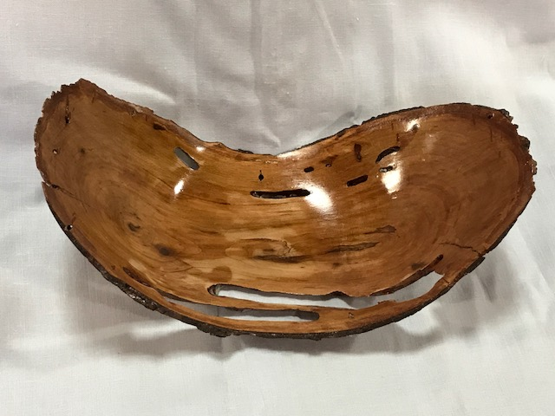
Cherry, 2.0 Length-to-Width Ratio Bowl

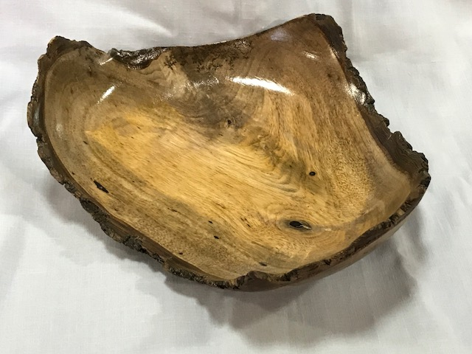
Persimmon Fork Bowl

