Hollow Egg with Sound Effects
By Paul Coppinger

Abstract: Wooden eggs are difficult to shape correctly on a lathe. This demo will present what makes a good shaped egg, will hollow it for lightness and will add sound effects for added uniqueness and, hopefully, with no cut lines showing and the figured grain aligned.
Tools:
Spur drive or equivalent
Live Center
Chuck with #3 jaws
Spindle roughing gouge
3/8” spindle gouge
Thin parting tool
Pencil
3/8” drill bit with chuck
Small hollowing tools
Calipers or Vernier calipers
Wood glue or medium CA glue & accelerator
Sound effects, beans, ball-bearings, etc
Sand paper to desired grit
Spray lacquer
Wax or finish
Procedure:
Place a figured side-grained block, approximately 3x3x5” on the lathe between the spur drive and live center. Turn the block into a cylinder with a spindle roughing gouge, stopping as soon as all flats are removed. Turn ¼” long tenons on each end to about a 1 ¾” diameter. Place into chuck.
Egg Shape
A good egg shape has a hemisphere on the large end and has a rounded point on the small end, see Fig 1, egg diagram.
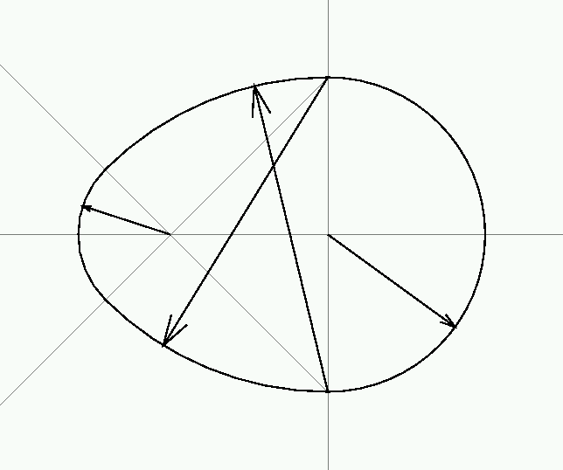Fig 1. Egg Shape
Separating the Block
Using a pencil, draw two reference lines close together about 1” from the live center tenon, see Fig 2. These will allow the grain to be aligned when the two parts are glued back together after hollowing. Using a narrow parting tool, separate the cylinder at the midpoint of the two lines. Try not to widen the cut to insure the grains match after glue-up.
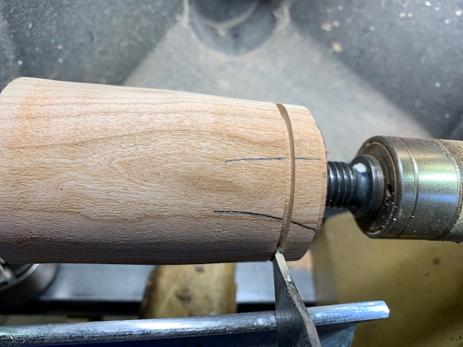
Fig 2. Separating the Cylinder
Using a spindle gouge, begin shaping the small end stopping about 1’ from the drive tenon. Do not turn away the pencil lines on the right end. This allow the wood to have mass at the drive tenon end while hollowing. Drill a 3/8” hole into the end, about 3” deep. Begin hollowing to produce an egg-shaped cavity leaving the walls about 1/4” thick and the 3/8” mortise opening with straight walls.
Mark the #1 jaw edges with a pencil to ensure the wood goes back into the chuck correctly.
Cutoff End Tenon
Place the smaller cutoff end of the block into the chuck. Using the calipers or Vernier calipers, measure the inside diameter of the hollowing hole on the bigger block. Add a little bit to the caliper diameter and scribe a circle on the end of the piece in the chuck by touching the pointed end to the left leg of the caliper about ¼” from the center. Do not let the right end of the calipers touch the wood. The right leg of the caliper should not align with the scribe mark. Move the left leg out and scribe another mark, checking to see the right leg aligns. Continue adjusting the left leg until the right leg aligns. This should make a circle slightly larger than the hollowing hole. Very carefully, using a parting tool, cut a 1/8” long tenon down to the scribe mark. Try fitting the hollowed piece. Continue carefully reducing the tenon by cutting a slight taper until it fits tightly into the hollowing hole.
Reassembly
Remove the cutoff end from the chuck and re-insert the hollowed piece into the chuck aligning to the #1 jaw pencil marks. Place 3 navy beans or 2 ball-bearing or equivalent for sound effects inside the cavity. Spray both surfaces with lacquer before gluing to act as a mask to keep the glue from filling the end grain. Place glue on the 3/8” mortise only. Insert the small block with the 1/8” long tenon into the hole and align the 2 pencil reference marks. This should align the figured grain. Use the live center to place tension on the glue joint and let the glue dry. If using CA glue, only place glue on the mortise and spray the 1/8” long tenon with accelerant. Quickly assemble as above.
Final Shaping and Finishing
After the glue dries, using a 3/8” spindle gouge, shape the right end into a hemisphere removing the small block until only the glued-in plug is left. The grain of the plug should match the bottom of the egg grain. Sand the hemisphere to the desired grit. For safety, a small inverted cone may be attached to the live center to support the wood. Then shape the small end of the egg per the diagram, until about a ¼” tenon remains next to the chuck. Sand to the desired grit. Wax or finish. Cut the ¼” tenon with a narrow parting tool to remove the egg. Clean the remains of the tenon with a knife or sandpaper. Wax or finish the cut off tenon.
Shake the egg for sound effects.
.

