Ball and Cup Toy
By Paul Coppinger
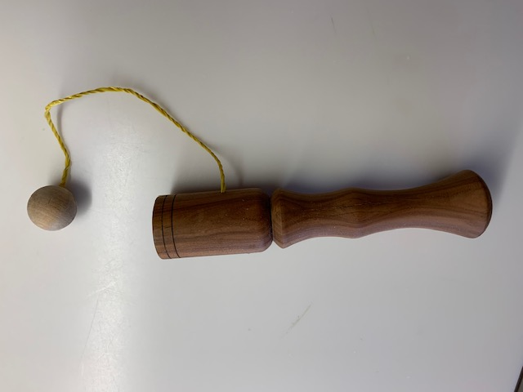
Abstract: This classic toy is easy to turn on any size lathe with minimum tools. The ball can be turned from a contrasting wood for visual effect.
Tools:
Chuck with #3 jaws
Live Center with small cone
Small bit and hand chuck
Small eyelet
Narrow parting tool
Nylon string
CA Glue
3/8” drill bit and chuck
Calipers or Vernier calipers
Small bedan or ¼” round skew or equivalent
Spindle roughing gouge
3/8” spindle gouge
Pliers
Sandpaper to desired grit
Wax or finish
Procedure:
The Ball
Place 1x1x3” block in chuck with corners between chuck jaws and tighten. Using 3/8” spindle gouge, turn a ball about ¾” diameter or less, leaving a small tenon on the jaw side. Use the small bit and hand chuck to drill a 1/8” deep hole in the end of the ball. Sand the ball. Screw an eyelet into the small hole. Use narrow parting tool to separate the ball at the tenon. Sand the bottom of the ball and wax or finish.
The Cup and Handle
Draw diagonals across one end of a 2”x2”x6” block and center punch a divot. Place into chuck with corners between chuck jaws. Use a live center into the divot to center the block in the chuck. Tighten the jaws. Using the spindle roughing gouge, turn the blank round, stopping as soon as all flats are removed.
The Cup
Drill a 3/8” hole about ¾” deep in the live center end. Using a bedan or small skew, open the hole to slightly larger and deeper than the ball diameter. Flare the edge of the hole. Sand and wax or finish the inside and flare of the hole. Insert the live center cone into the flared hole for support.
Completion
Using the 3/8” spindle gouge, shape the outside of the cup into a long shallow cove. Then shape the handle with a “V” groove below the cup. The bottom can be a ball shape or straight to allow the toy to stand. Sand and wax or finish. Part using a parting tool.
Using nylon string, tie one end of about a 12” piece to the eyelet of the ball and the other end around the “V” groove below the cup. Place a drop of CA glue on both knots.

